What is Elastic Load Balancing?
Elastic Load Balancing automatically distributes your incoming traffic across multiple targets, such as EC2 instances, containers, and IP addresses, in one or more Availability Zones. It monitors the health of its registered targets, and routes traffic only to the healthy targets
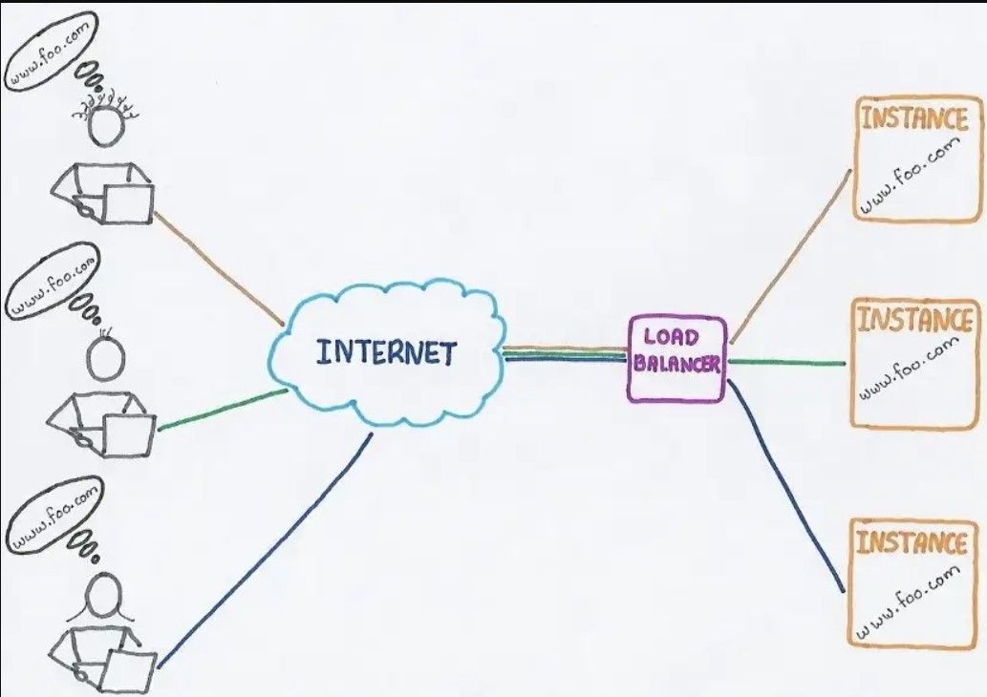

ELB Types
Application Load Balancer (ALB)
Network Load Balancer (NLB)
//Gateway Load Balancer (GWLB)
Classic Load Balancer (CLB)

ELB Target Types
ELB distribute incoming traffic to:
Instances (EC2, EC2 with Auto Scaling, Containers with ECS)
IP addresses (VPC Subnets, RFC 1918 CIDR, On-premises with Direct Connect or Site-to-Site VPN)
Lambda functions (for ALB type)
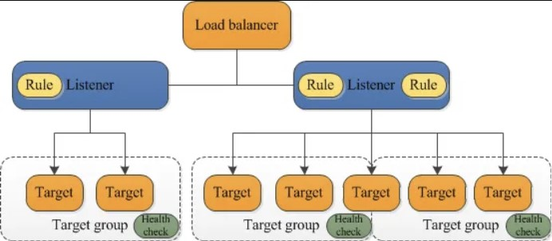
ELB load balancer serves as a single point of contact for clients and distributes incoming application traffic across multiple healthy registered targets, such as EC2 instances, in multiple Availability Zones.
Listeners:
Listener checks for connection requests from clients, using the protocol and port that you configure.
Listener defines how your inbound connections are routed to your target groups based on rules.
For every load balancer, you must configure at least one listener.
Rules: The rules that you define for a listener determine how the load balancer routes requests to its registered targets.
Each rule consists of a priority, one or more actions, and one or more conditions.
Each listener has a default rule, and you can optionally define additional rules.
Target Groups:
A target group is a group of resources that you want your ELB to route request to.
You can configure your ELB with a number of different target groups, each associated with different listener configuration and associated rules.
Each target group routes requests to one or more registered targets, such as EC2 instances, using the protocol and port number that you specify.
You can register a target with multiple target groups.

Difference between ALB & NLB
Application load balancing operates at Layer 7, the application layer. An application installed on a server examines each incoming request, such as HTTPS or SMTP requests. Application load balancing can direct requests toward one of the servers best able to satisfy the request.
Network load balancing operates at Layer 4, the transport layer, and supports protocols like TCP and User Datagram Protocol (UDP). It has a very high performance

